USER CONFIGURABLE MULTI-SOFTWARE SHORTCUTS KEYBOARD

Course Title : Embedded System Design
Team Members :
1. Aaron Peter (CB.EN.P2EBS25001)
2. Subikshaa U K (CB.EN.P2EBS25030)
Date : 07/11/2025

REQUIREMENT ANALYSIS
To gather insights, a structured Google Form survey was distributed among individuals who spend significant time using laptops and desktops. A total of 36 valid responses were collected. The questionnaire included sections on user information, current challenges in using shortcuts, desired features in a customizable system, interface preferences, and open-ended feedback.
Survey Overview
Parameter | Details
Total Responses | 36 (till now)
Data Collection Tool | Google Forms
Target Group | Frequent laptop/desktop users
Duration of Survey | -
Type of Questions | Multiple Choice, Checkbox, Short answers

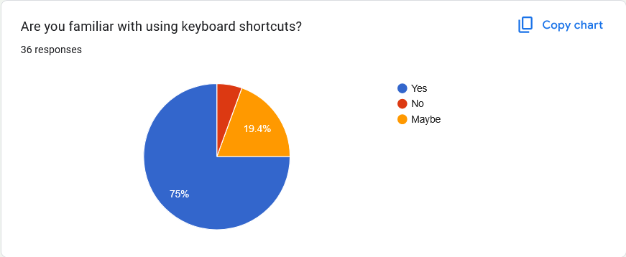
Insight 1: Familiarity with Keyboard Shortcuts
Nearly 75% of the participants indicated that they are familiar with using keyboard shortcuts. This demonstrates that the majority of users recognize the importance and efficiency of shortcuts in daily computer usage.
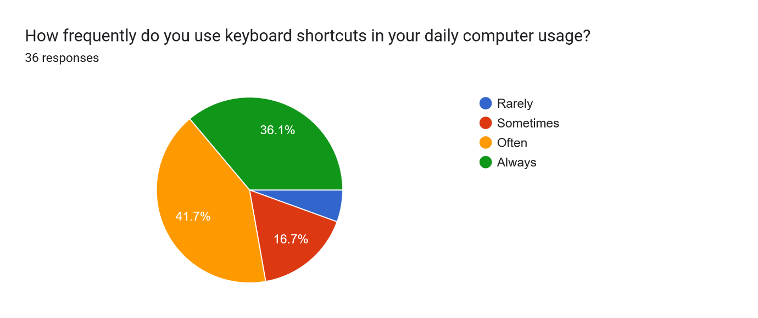
Insight 2: Frequency of Shortcut Usage
Around 36.1% of participants use keyboard shortcuts frequently in their daily tasks. Meanwhile, 41.7% reported using them sometimes, and 16.7% use them occasionally. This shows that a significant proportion of users actively rely on shortcuts for improved productivity.
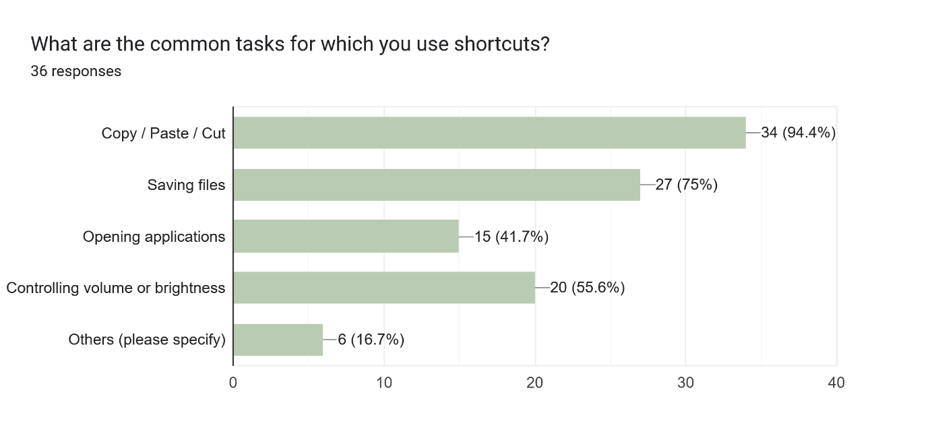
Insight 3: Common Shortcut Operations
A vast majority — about 94.4% of participants — identified Copy, Paste, and Cut operations as the most common tasks for which they use shortcuts. This suggests that users primarily associate shortcuts with essential text-editing or document-handling operations.
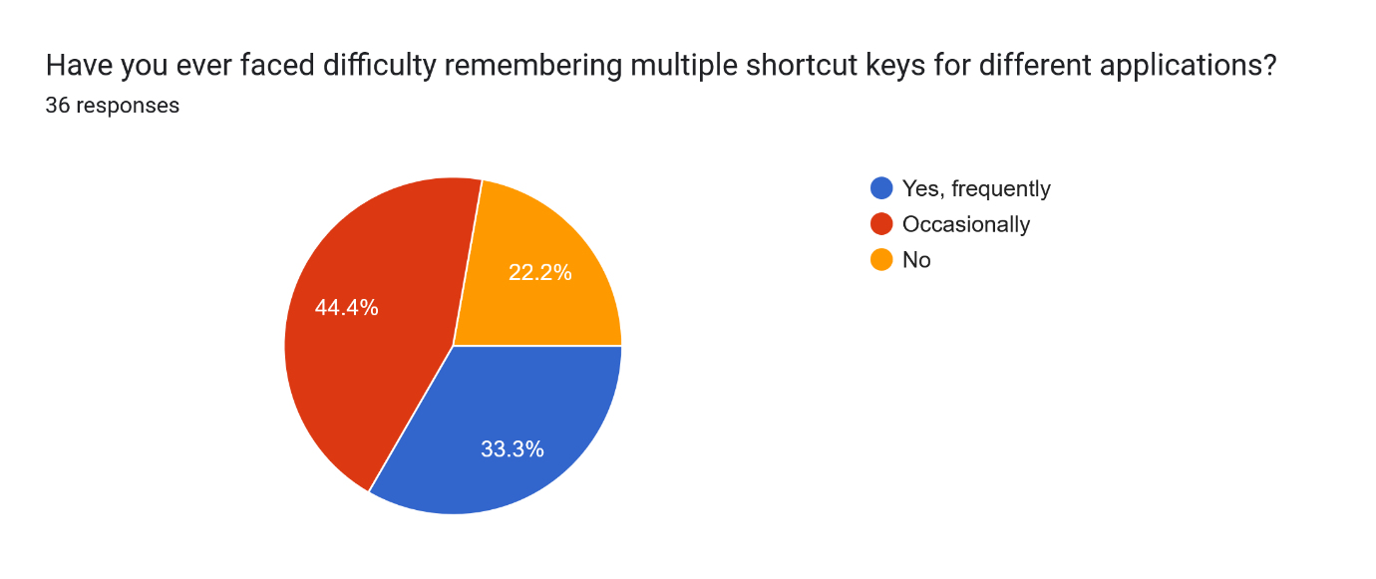
Insight 4: Memory Challenges in Shortcut Usage
When asked about their experience with remembering shortcuts, 33.3% of respondents admitted that they frequently forget multiple shortcut combinations across different applications, while 44.4% stated that this happens occasionally.
This indicates that memorizing shortcuts for various software applications remains a significant challenge for many users.
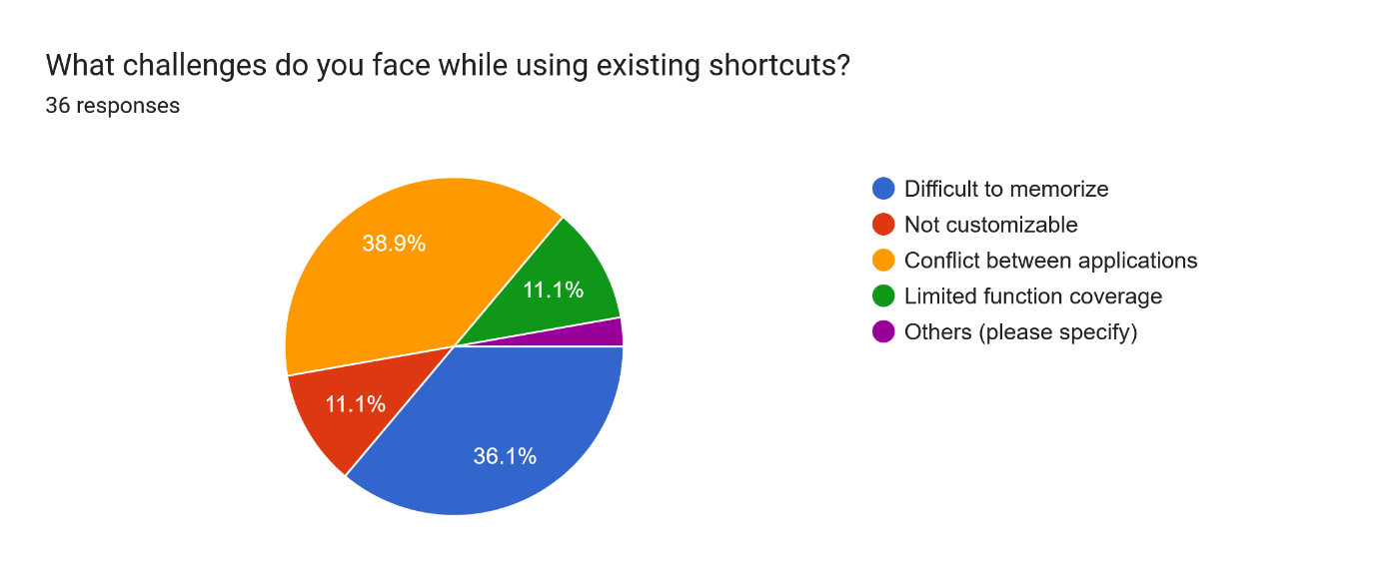
Insight 5: From the responses, it was observed that:
- 38.9% of respondents reported conflicts between applications as the main challenge when using existing shortcuts.
- 36.1% found it difficult to memorize multiple shortcut combinations.
- 11.1% felt that existing shortcuts are not customizable.
- 11.1% indicated limited function coverage as an issue.
- A very small portion mentioned other challenges.
This indicates that the primary pain points are memorability and conflicts between applications, highlighting the need for a system that is flexible and easily configurable.
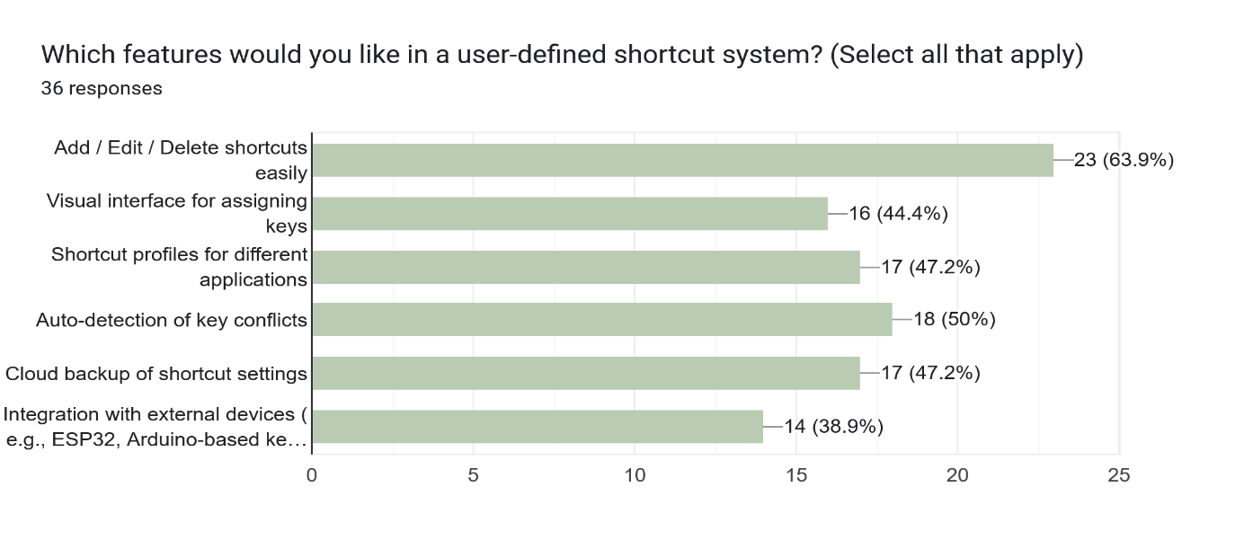
Insight 6: Respondents were asked to select all features they would like in a customizable shortcut system. The results are as follows:
- Add / Edit / Delete shortcuts easily: 63.9% (23 respondents)
- Auto-detection of key conflicts: 50% (18 respondents)
- Shortcut profiles for different applications: 47.2% (17 respondents)
- Cloud backup of shortcut settings: 47.2% (17 respondents)
- Visual interface for assigning keys: 44.4% (16 respondents)
- Integration with external devices (e.g., ESP32, Arduino-based keypad): 38.9% (14 respondents)
These results suggest that users highly value customizability and conflict management, along with the ability to maintain profiles for different applications. Visual feedback and cloud backup are also important, while hardware integration is desired by a smaller but significant portion of users.

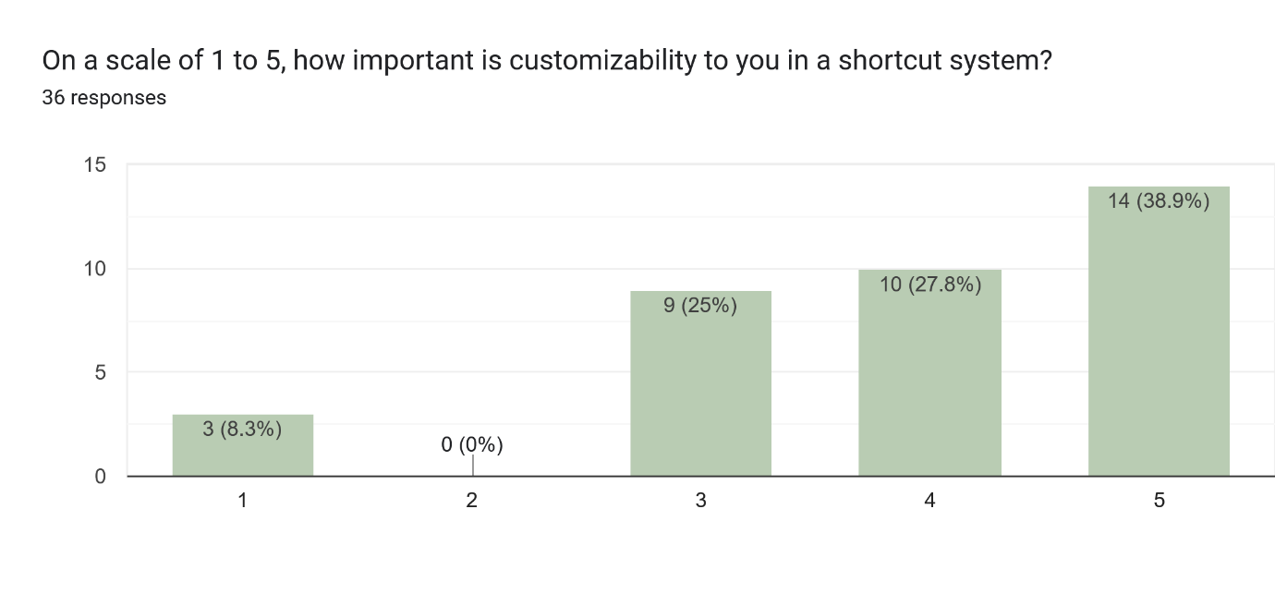
Insight 7: Importance of Customizability
Among 36 participants, more than 38.9% considered customizability an essential aspect of an effective shortcut system. This emphasizes the demand for user-driven personalization and flexibility in shortcut creation.
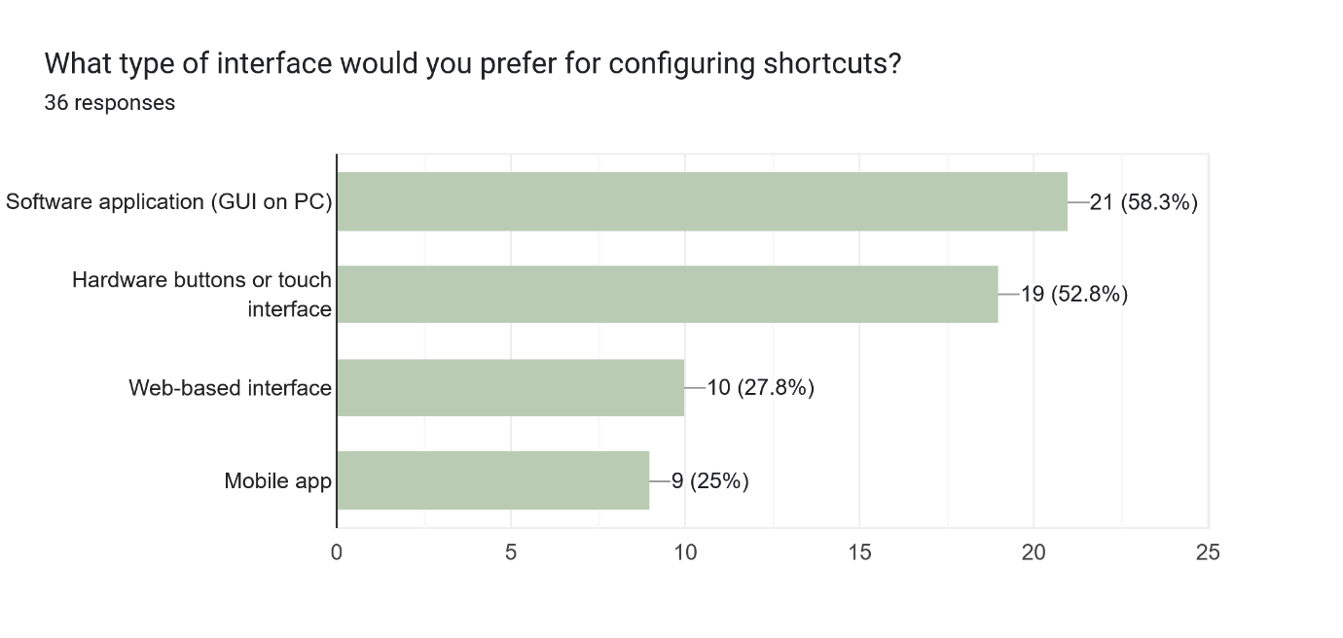
Insight 8: Preferred Mode of Implementation
When given a choice of interface preference:
- 58.3% (21 participants) preferred a software-based GUI application on PC.
- 52.8% (19 participants) showed interest in hardware-based buttons or touch interface.
This indicates a near-equal preference, suggesting a hybrid solution (both software GUI and hardware keypad) would cater to a wider range of users.
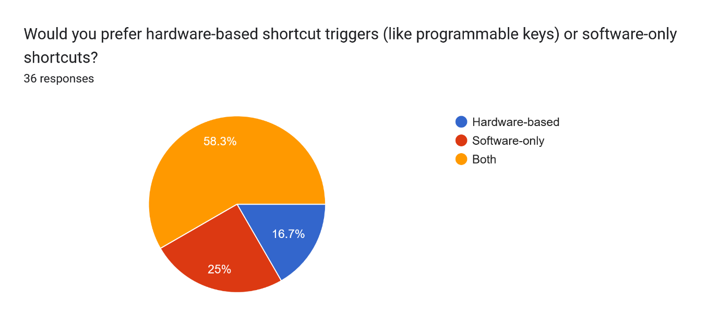
Insight 9: Preferred Mode of Implementation
When given a choice of hardware and software based shortcut triggers:
- 58.3% (21 participants) preferred a software-based GUI application on PC.
- 52.8% (19 participants) showed interest in hardware-based buttons or touch interface.
This indicates a near-equal preference, suggesting a hybrid solution (both software GUI and hardware keypad) would cater to a wider range of users.

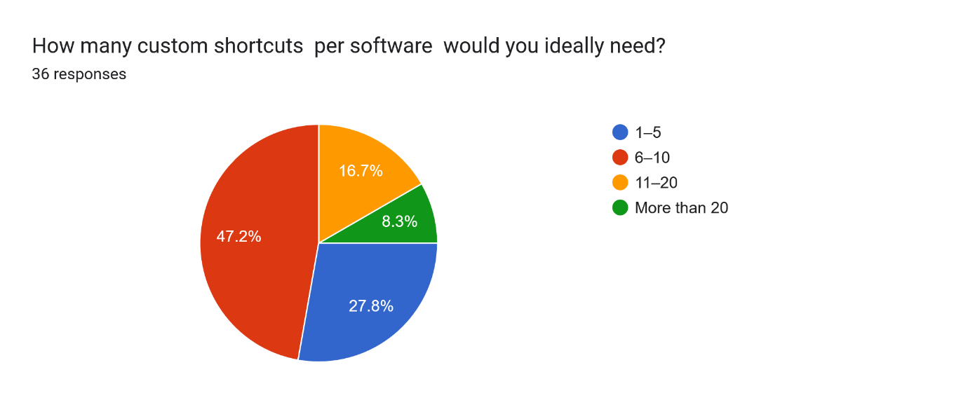
Insight 11: At an average, about 47.2% of the participants needs 6-10 shortcuts per software application.
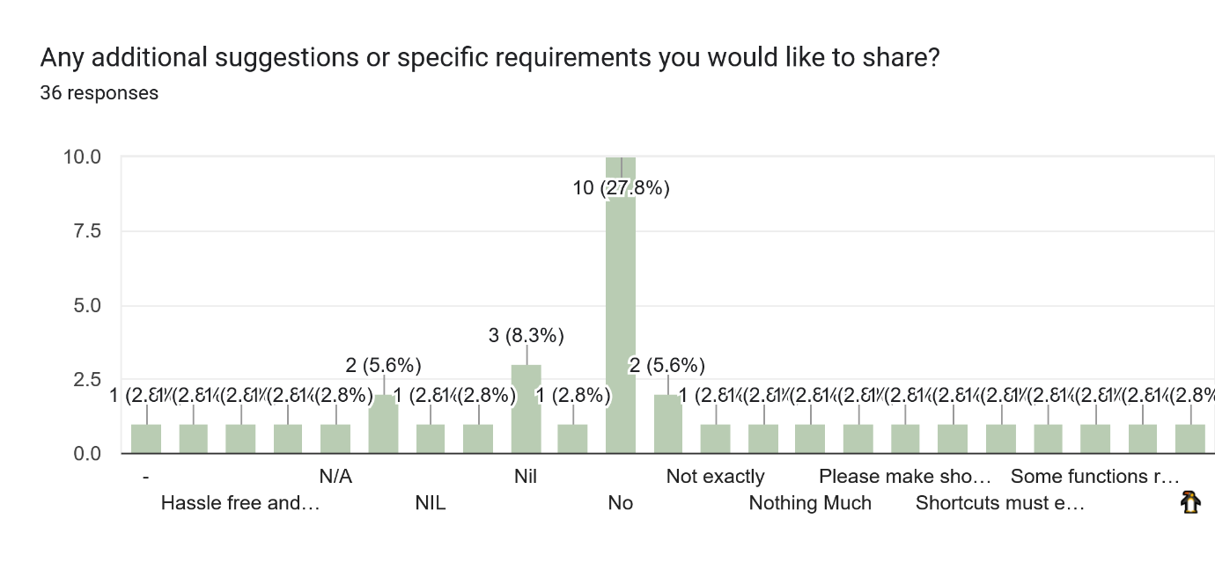
The participants were asked about the feedback about this user configurable keyboard applications.
- Shortcuts must easily rememberable and single key application or max 2 key
- Short cut keys are mostly need for editors
- Shortcuts that are not Layout specific
- I’d like a shortcut system that can sync across multiple devices and operating systems, supports gesture-based triggers, and offers quick suggestions for unused key combinations.
- Please make shortcuts for selecting multiple pages at a time for different colour printouts
- Some functions require pressing too many keys simultaneously. Maybe a key to first enable one more for those shortcuts that are minimum.
- Hassle free and easy to understand applications are better.
- Customization option

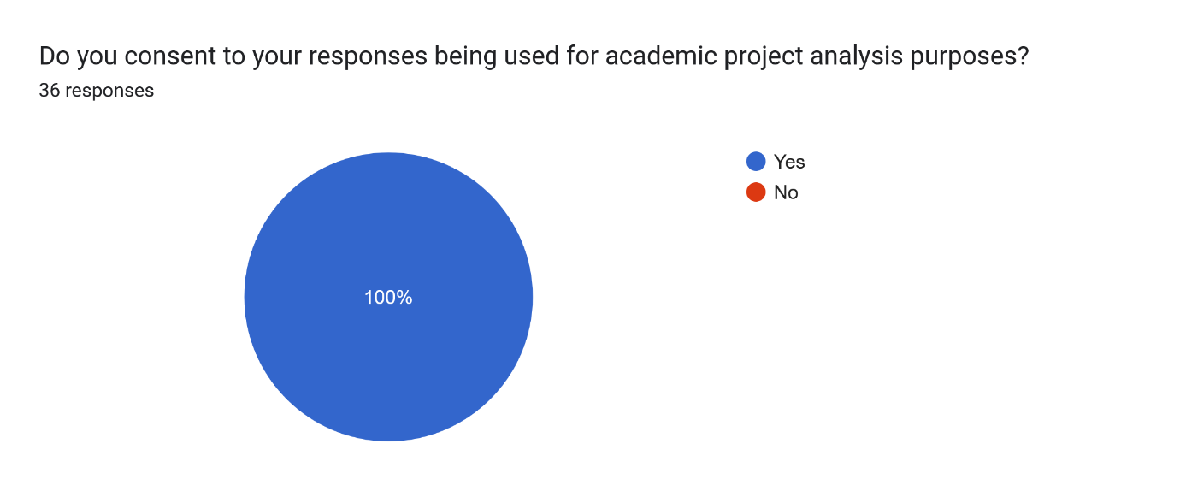
REQUIREMENT ANALYSIS TABLE
S. No. | Issues Faced by Users | Possible Solution / Approach | How Our Project Solves It | Expected Outcome / Benefit
1 | Difficulty in remembering multiple shortcut keys for different applications (36.1%) | Introduce a centralized shortcut management system with clear visual mapping. | The user-configurable keyboard provides dedicated buttons with an LCD display showing the current software and shortcut name. | Users can easily identify shortcuts without memorizing them, improving productivity.
2 | Shortcut conflicts between different applications (38.9%) | Implement conflict detection and isolated shortcut profiles for each software. | Each software (Word, Chrome, Arduino, WhatsApp) has a separate shortcut mode, selected via the hardware interface. | Prevents overlapping commands and ensures smooth switching between applications.
3 | Lack of customization options (11.1%) | Allow users to add, delete, or edit shortcuts as per their preference. | The system supports user-configurable shortcuts through a programmable interface or companion software. | Enhances user flexibility and control over shortcut assignments.
4 | Limited function coverage (11.1%) | Extend shortcut support beyond basic copy/paste to include multi-level functions. | Provides 32 keys per software, covering a wide range of functions including system and custom commands. | Enables full operational control without frequent keyboard switching.
5 | Difficulty in managing shortcuts visually | Provide a GUI or LCD-based feedback system for shortcut indication. | Integrated I2C LCD display shows active software and pressed key function. | Offers real-time visual feedback and reduces user confusion.
6 | Frequent forgetting of shortcuts (33.3%) | Introduce reminders, on-screen hints, or labeling systems. | Each key can be labeled, and LCD dynamically displays shortcut details. | Reinforces memory and ensures quick recall during operation.
7 | Need for cross-software flexibility | Create shortcut profiles per application. | Profiles for Word, Chrome, Arduino, WhatsApp can be switched instantly using mode selection keys. | Users can seamlessly transition between applications.
8 | Fear of losing settings / reconfiguration effort | Enable backup or persistent memory for shortcuts. | Planned inclusion of EEPROM storage or cloud backup for shortcut settings. | Ensures data retention even after power loss.
9 | Desire for automation and efficiency | Automate repetitive operations using single-touch controls. | Each shortcut key triggers pre-defined commands or key combinations instantly. | Reduces task time and boosts efficiency.

